Terraform

1. Install on Fedora

sudo dnf config-manager --add-repo <https://rpm.releases.hashicorp.com/fedora/hashicorp.repo>

sudo dnf install terraform

1. Create the folder + .tf config file

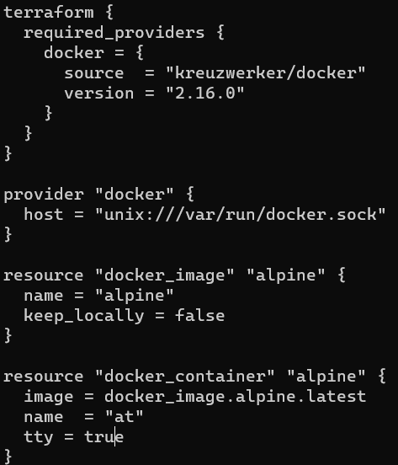

1. Use terraform init

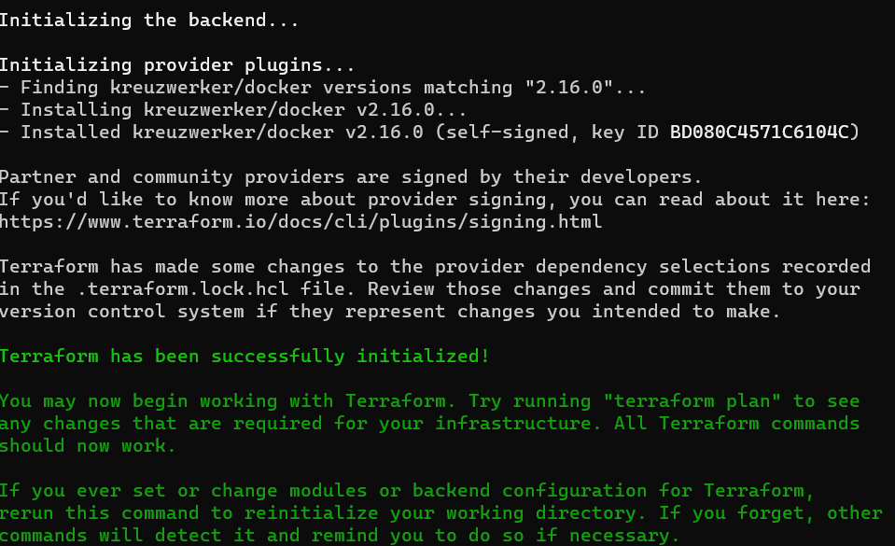

1. Use terraform validate to check if everything is okay



1. Use terraform plan to check out what the program is going to do
2. Use terraform apply so it brings up the container

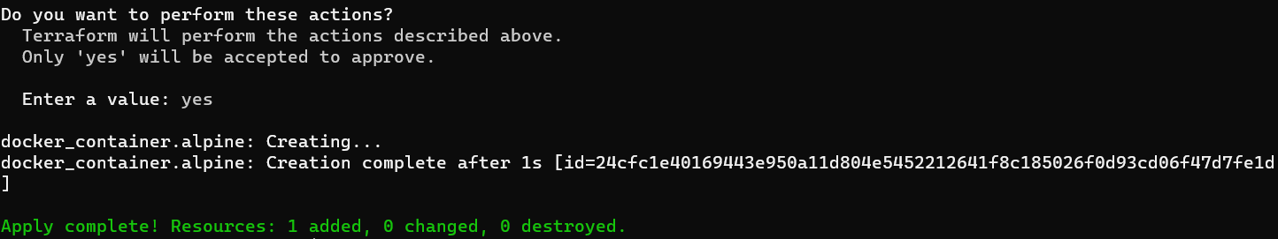

1. Check docker container ls to see if its working



1. Copy the terraform.tfstate with scp



1. Terraform destroy to tear the whole thing down

